**DAILY ONLINE ACTIVITIES SUMMARY**

|  |  |  |  |  |  |  |  |  |
| --- | --- | --- | --- | --- | --- | --- | --- | --- |
| **Date:** | **30-05-2020** | | | | | **Name:** | **Pavana P** | |
| **Sem & Sec** | **6A** | | | | | **USN:** | **4AL17CS057** | |
| **Online Test Summary** | | | | | | | | |
| **Subject** | | **Python** | | | | | | |
| **Max. Marks** | | **30** | | **Score** | | | **14** | |
| **Certification Course Summary** | | | | | | | | |
| **Course** | **Introduction to Ethical Hacking.** | | | | | | | |
| **Certificate Provider** | | | Great learning Academy | | **Duration** | | | 6.5 hours |
| **Coding Challenges** | | | | | | | | |
| **Problem Statement:**  1.Python program to read a number and print the pattern  2. write a java program to Count number of trailing zeros in product of array | | | | | | | | |
| **Status: Completed** | | | | | | | | |
| **Uploaded the report in Github** | | | | | **YES** | | | |
| **If yes Repository name** | | | | | **DAILY STATUS** | | | |
| **Uploaded the report in slack** | | | | | **YES** | | | |

.

**Online Test :**

Subject:-Python

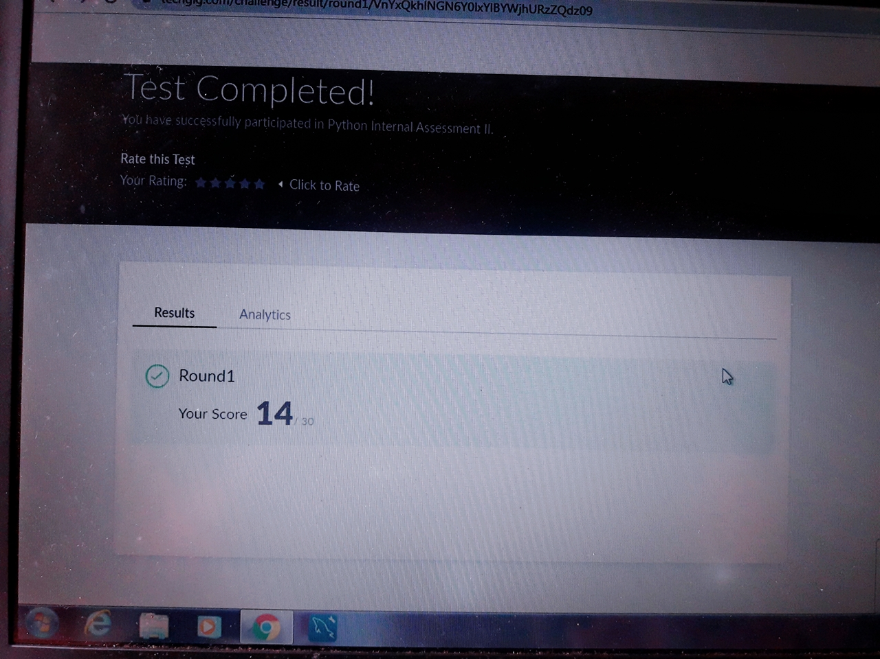

**Certification Course Details:**

**Introduction to Ethical Hacking:**

Today I have Completed this course.

.

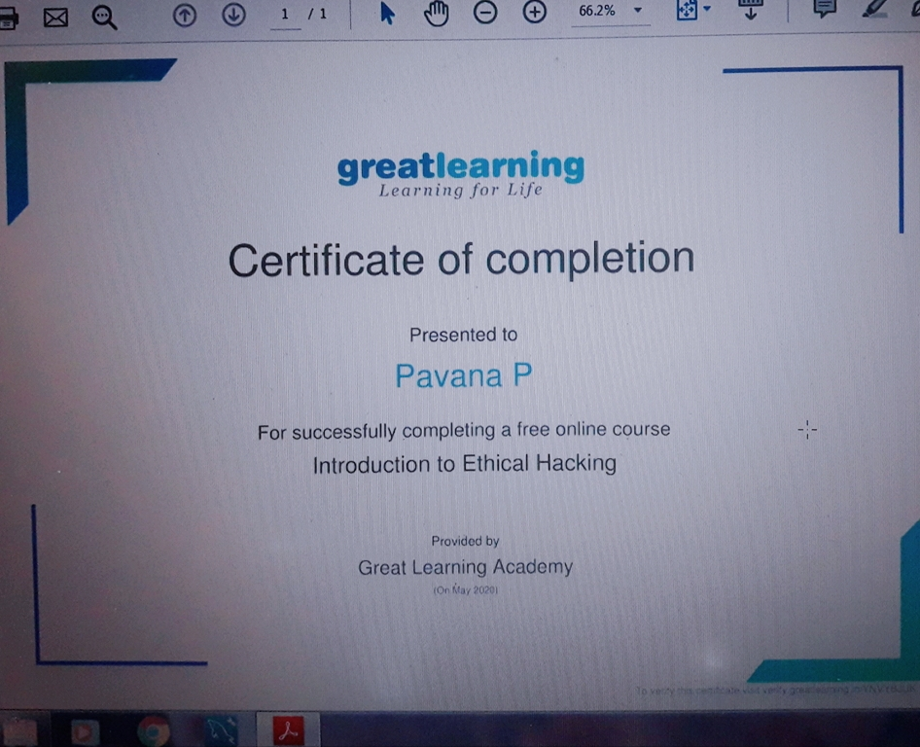

**Coding Challenges Details:**

**https://github.com/pavana-p-kulal/DAILY-STATUS/tree/master/30-5-20/Online%20Coding**